2018 WHA Antimicrobial Stewardship Journal Club Series - Journal Club #1:
“When to Test and When to Treat—A Deep Dive on Asymptomatic Bacteriuria”
April 12, 2018

Dear Participant:
Thank you for your participation in our Journal Club. Please complete the attestation form at http://www.go2certificate.com to receive the contact hours earned. This activity awards 1.0 contact hour for physicians.

** NOTE: We recommend the use of Chrome for an optimal portal experience. **

The portal will be active until May 12, 2018 at 5:00 pm ET. Please claim your certificate(s) by this date/time.

In future visits, the system automatically recognizes your account based on your email address. It will ask you to enter your own created password after you have entered the event’s Access Code and your email address.

- Please visit http://www.go2certificate.com
- Enter Access Code: 589-JC1
- Enter your email address
- Click the ‘Next’ button
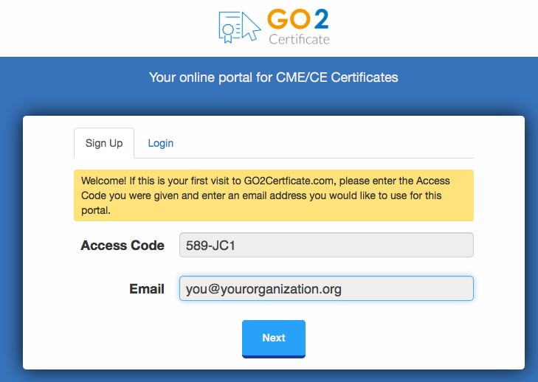

- Complete demographic information and setup a password. Click the ‘Next’ button.
- Select the Activity you attended by clicking the box to the left of the activity title. There is only one activity for this access code. Please click the box.

- Click the ‘Next’ button. Your evaluation will load.

- Complete the Activity Evaluation and use the ‘Next” buttons to proceed through the evaluation. At the end of the evaluation, please click the “Submit’ button.

- Confirm how you would like your name to appear the certificate.

- Select the box requesting the accreditation you wish to earn.
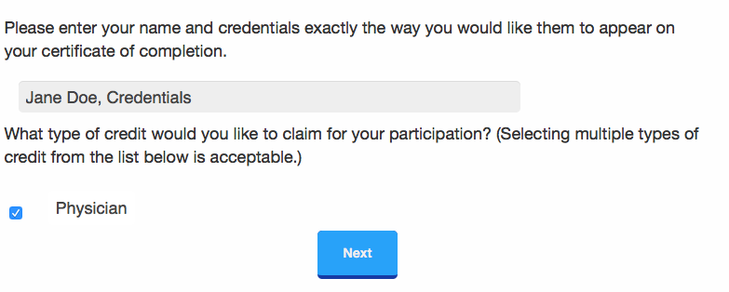

- Click the ‘Next’ button.

- Confirm/attest to your 1.0 hour of participation. Using the dropdown arrow, physicians should claim only the credit commensurate with the extent of their participation in the activity. Click the ‘Next’ button.

- Click ‘VIEW’ to open and print your certificate. You may also email your certificate to yourself. In addition, your certificates will be hosted on our website and can be accessed as many times as you like using the “Login” option on the main page.

Questions?? Please email info@axismeded.com for assistance.

